Intrusion detection system in NetSim

**Software Recommended:** NetSim Standard v11.1 32-bit/ 64-bit, Visual Studio 2017

The following steps show how a user can run the IDS in NetSim to detect a malicious node, and then setup a new route to the destination avoiding the malicious node

* Creating Malicious nodes for a particular network scenario is explained in Malicious.c file
* To detect the intruder and to send data via a new route, the following files are added in DSR and IEEE802_11:
  + **Pathrater.c** :

This file contains code for avoiding the malicious node and finding a new route (once the IDS detects the malicious node) in networks running DSR in Layer 3. Note that this system would work only for UDP and not for TCP, since TCP involves receiving ack’s from the destination

If _NETSIM_PATHRATER_ is defined, the code is used to validate routes. When the Node is a Malicious Node and a Route Reply is processed, the Function

verifies the route reply in the route cache and checks for the black listed node

i.e.,malicious node. When a malicious node is found, that route entry is deleted from

the cache.

* + **Watchdog.c**

This file contains code for the IDS and is added in IEEE802_11 operating in Layer 2.

If _NETSIM_WATCHDOG_ is defined, a watchdog timer starts the moment a packet is sent. Once a packet is forwarded to next hop node, the current node checks for watchdog timer duration if the packet is getting forwarded further on to destination node or not.

The malicious node doesn’t forward packets that it receives. The watchdog timer in the node (which forwarded the packet to the malicious node) expires. A counter is present which measures the number of times the watchdog timer expires (in other words the number of packets sent out but not forwarded by the next hop node). Once this counter’s value reaches cous node) expires.nd then setup a new route to the de/. Once ththe failure threshold the next hope is marked by the current node as a malicious node.

* After you unzip the downloaded project directory, Open NetSim Home Page click on **Open Simulation** option,

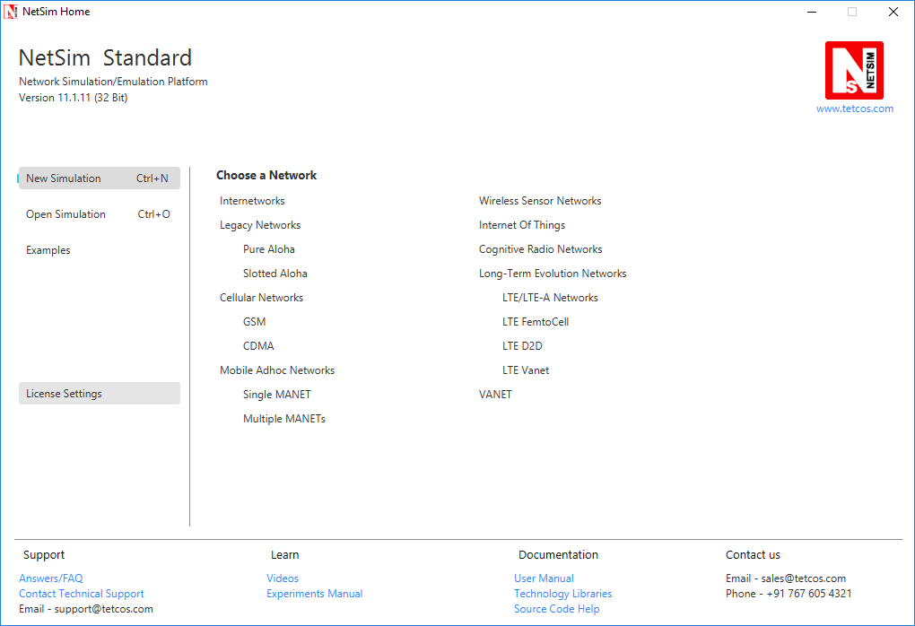

* Click on **Workspace options**

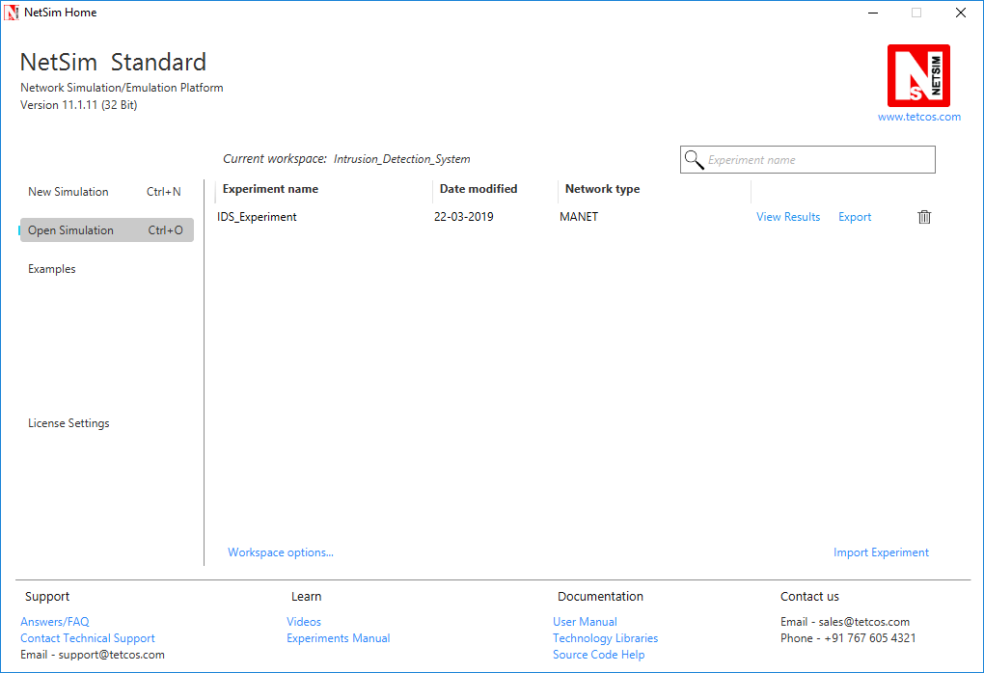

* Click on **More Options,**

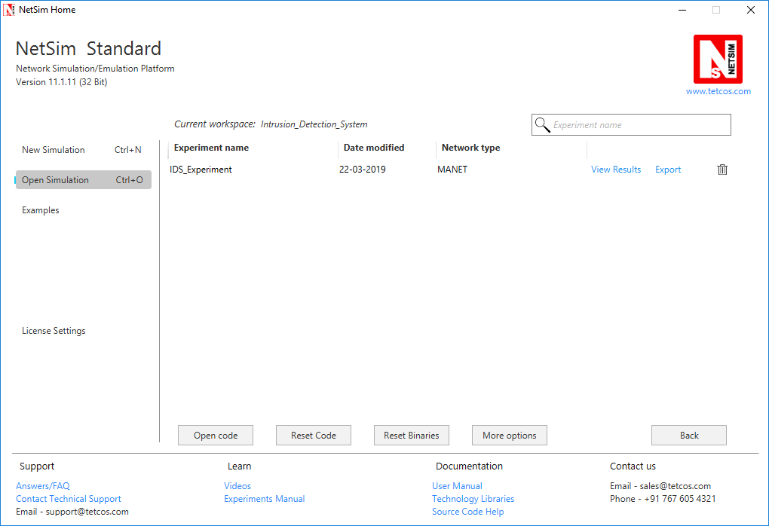

* Click on **Import**, browse the extracted folder path and go into Intrusion_Detection_System workspace directory. Click on Select folder button and then on **OK.**

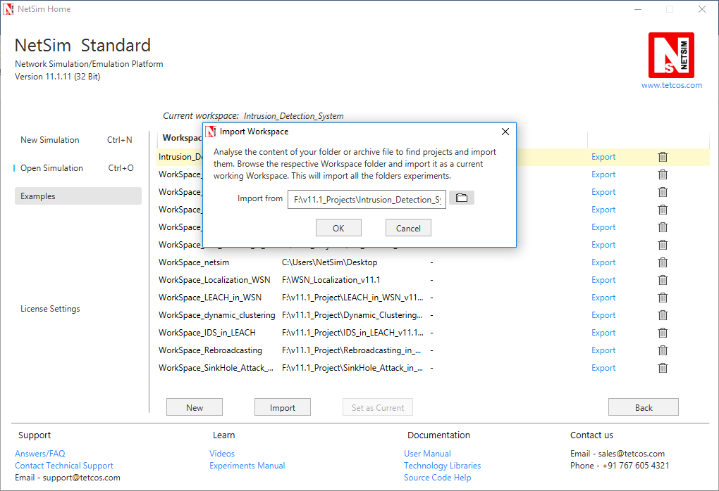

* While importing the workspace, if the following warning message indicating Software Version Mismatch is displayed, you can ignore it and proceed.

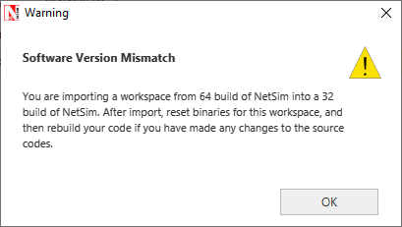

* Go to home page, Click on **Open Simulation** 🡪 **Workspace options** 🡪 **Open code**

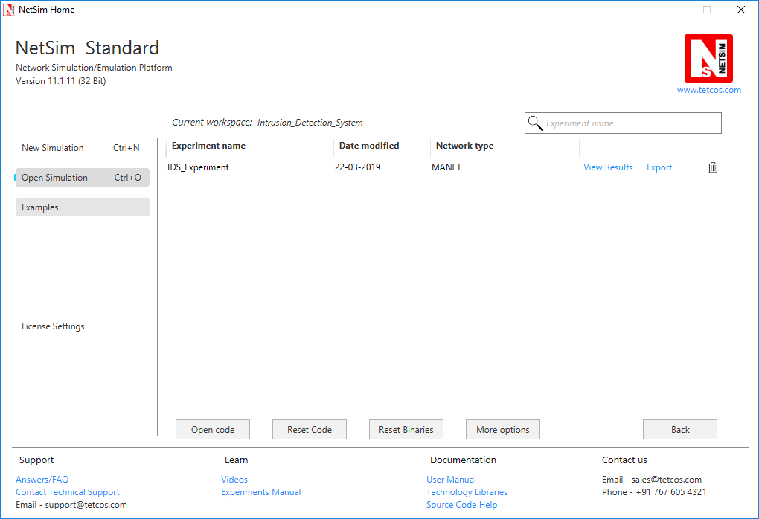

* Right click on the solution and select rebuild.

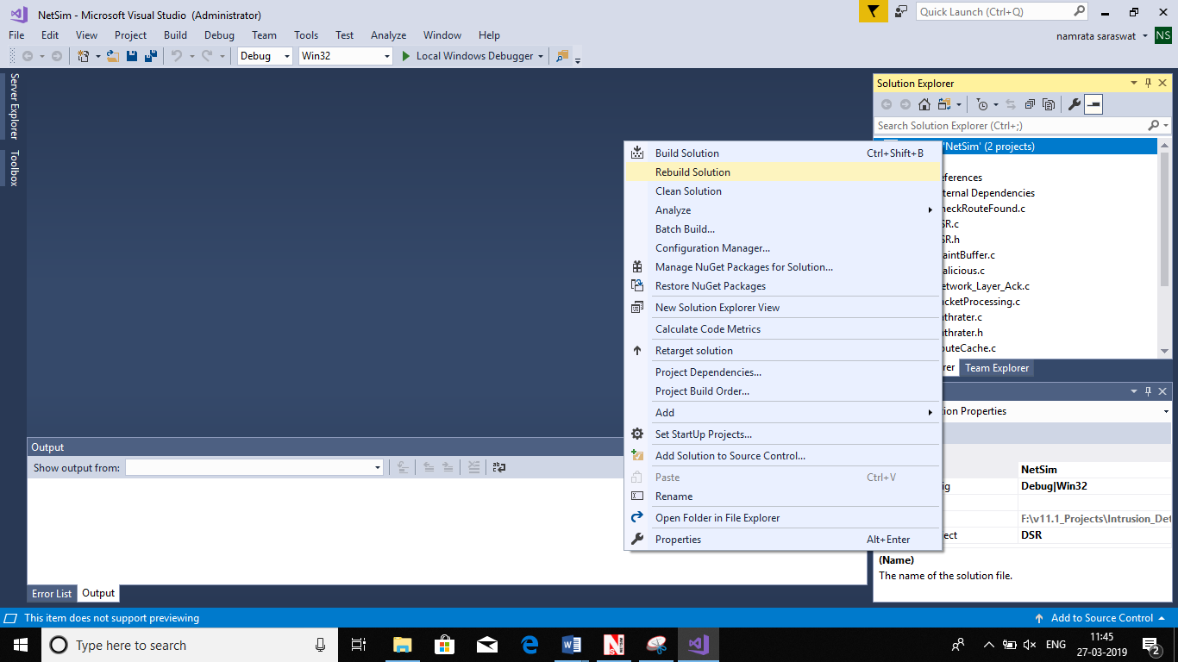

* Upon rebuilding, **libIEEE802_11.dll** and **libDSR.dll** will automatically get updated in the respective bin folder of the current workspace.

**Note:**

1. While on whether you are using NetSim 32 bit or 64 bit setup you can configure Visual studio to build 32 bit or 64 bit Dll files respectively as shown below:

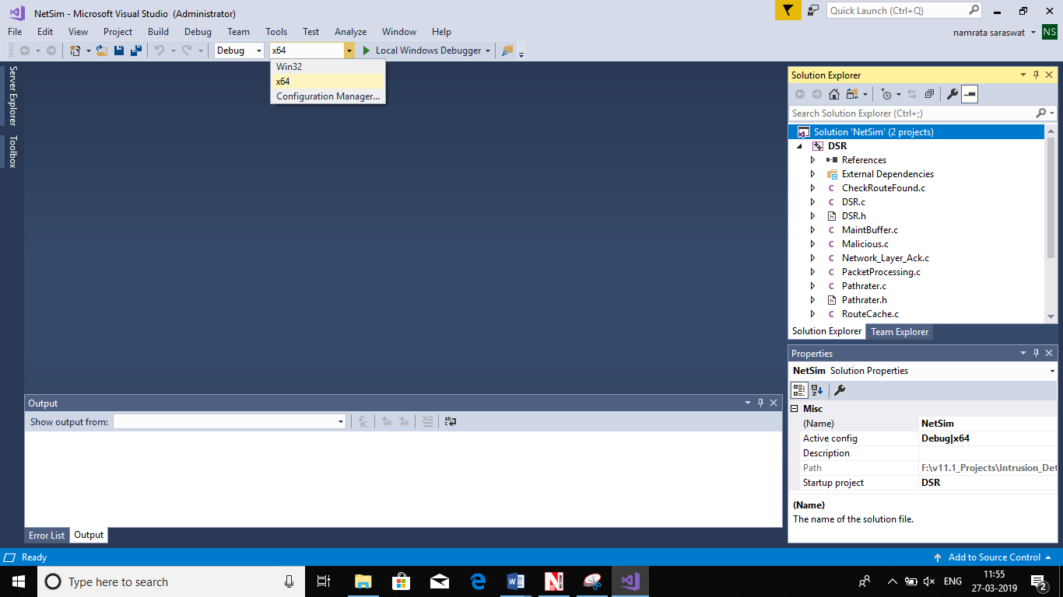

1. While importing the project in NetSim 64bit version, it will display popup as **“Software version mismatch”,** ignore the warning message and click in **ok.**

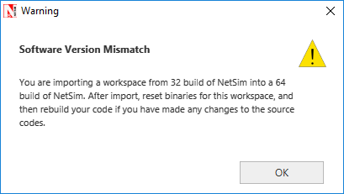

Next, to run the IDS code, follow these steps:

**Step 1:** Go to NetSim home page, click on **Open Simulation**, Click on **IDS_Experiment**.

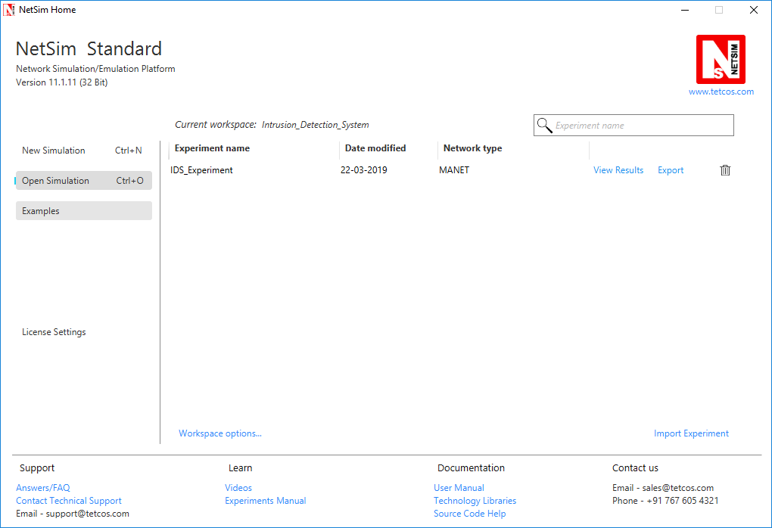

Malicious

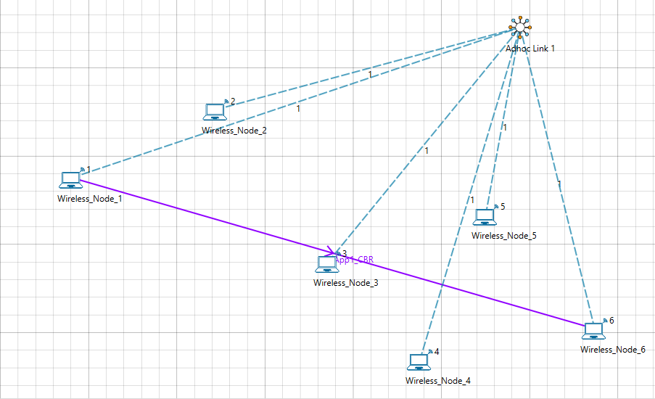

**Step 2:** Channel Characteristics is set to Pathloss only with LOG_DISTANCE as the path loss model. Path loss exponent is set to a high value 3

Example:

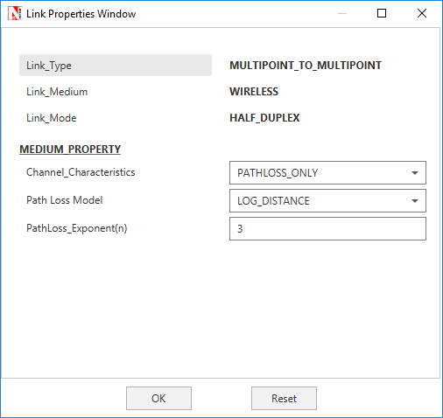

**Step 3:** An application is set between node 1 and node 6

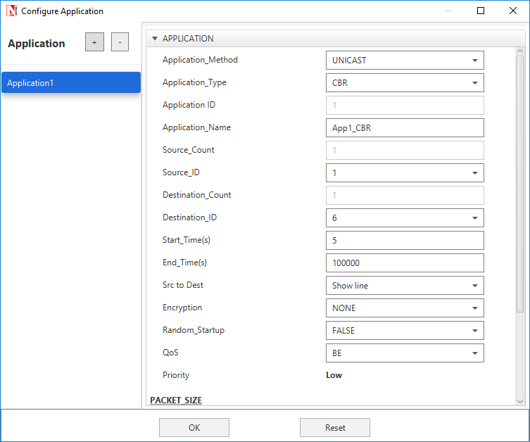

**Step 4:** Run the simulation

**Step 5:** View packet animation. Here you would notice initially all traffic would flow to the malicious nodes. Per the original code setting the Watchdog timer is set to 2 seconds and the failure threshold is set to 20 packets. So you would notice that around 25.76 seconds, the malicious node is detected and the route to destination would change in the subsequent route discovery process.

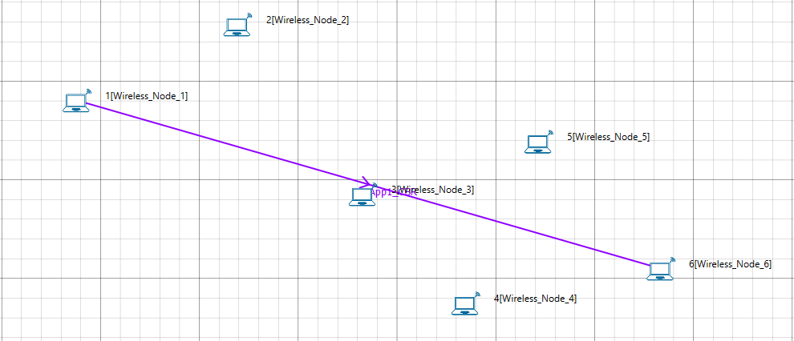

Initial flow of packets till node 2 detected as malicious



Flow of packets after node 2 is detected as malicious

The time at which a malicious node is detected can be obtained from the CUSTOM METRICS in the results window where the start time - time from which a node becomes malicious, detection time - time at which the node was added to blacklist can be obtained.

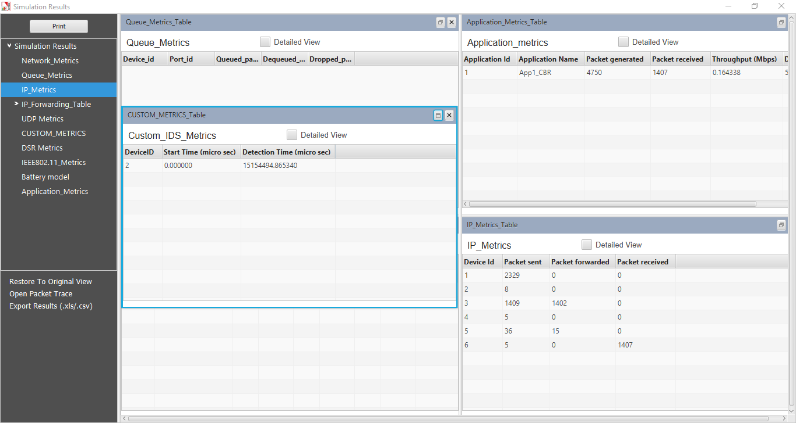

Dedicated Metrics for IDS